**To make a local branch identical to some other branch**

See “Replacing all branch history/contents” - <https://sethrobertson.github.io/GitFixUm/fixup.html>

> git reset -–hard <commit-hash>

**This will remove all commits after the specified commit-hash!**

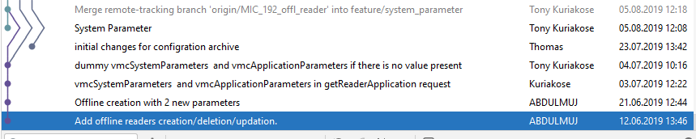

**Resetting remote to a certain commit**

<https://stackoverflow.com/questions/5816688/resetting-remote-to-a-certain-commit>

> git push –f origin master

**The –f (force) command will push an exact copy of the local branch as it is to the remote removing any commit from the remote that does not exist in the local branch!**

